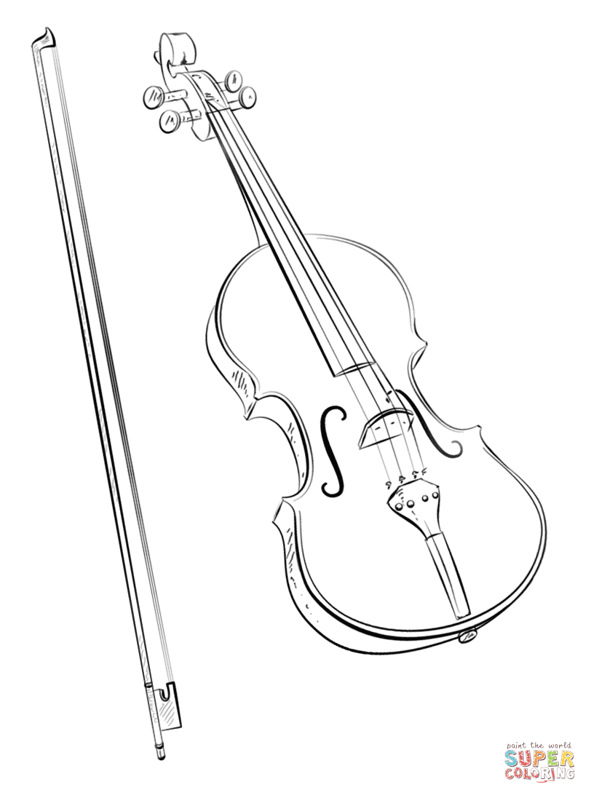

to the St. Johns High School

**Where Can I Find Orchestra Information throughout the Year?**

**Infinite Campus Email Messages**

* + Mrs. Parker will send group messages through Infinite Campus often. Make sure all off your family’s email addresses are accurate in Infinite Campus.

**Google Classroom**

* + Students will sign up in orchestra class

Go to **www.sjorchestras.weebly.com** for current orchestra information.

Find us on **Facebook** at “**St. Johns Orchestras**” or on **Instagram** at “**stjohnsorchestras**”

**1ST Homework Assignment:** Due Monday, September 18

1. Review this handbook with your parent/guardian.
2. Be sure to hit the main points:
   * **Instrument Rental Info + shoulder rest/rockstop**
   * **Instrument Care and Accident Repair**
   * **Required Concert Dates (put them on your family calendar)!**
   * **Policy for Excused/Unexcused absences**
   * **Concert Outfit**
3. Fill out the Student & Parent Agreement (Back of Handbook) and turn it in by **Monday, September 18.**

|  |
| --- |
| Mrs. Jennifer Parker ⦁ Orchestra Room ⦁ parkerj@sjredwings.org ⦁ 989.227.4275 |
| Concert Orchestra ⦁ Symphony Orchestra  Instruments: Violin, Viola, Cello, Bass  These classes have additional requirements outside of the normal school day, including **concerts, festivals, clinics, and field trips.** |

Orchestra

*Welcome*

**Home Practice**

Your brain learns the skills to play an instrument through **repetition** (practice)

* **Home practice is expected every week during the trimester. 15-20 min. per practice session and 3-5 sessions a week are encouraged.**
* **Mrs. Parker will have different types of assessments throughout each marking period to help students achieve the goals in orchestra.**

**Daily Instrument Care**

DO put your instrument in its case whenever you are done practicing (loosen bow)

DO wipe the rosin off of your instrument after each practice session with a soft cloth (no cleaning or dusting solution)-**Alcohol-based products will ruin the instrument’s wood and varnish!**

DO ask your orchestra teacher questions about your instrument

DON’T use alcohol of any kind on your instrument. It will damage the wood/varnish

DON’T leave your instrument in the car, outside, in sunlight, or near vents/windows

DON’T touch or move someone else’s instrument without their permission

DON’T let anyone but your orchestra teacher or a luthier play or “fix” your instrument

**Orchestra Grading**

40% - Daily Musicianship/Rehearsal Skills

30% - Concert Attendance, Dress, Etiquette

30% - Assessments, Assignments, Practice

A 93-100% C 73-76%

A- 90-92% C- 70-72%

B+ 87-89% D+ 67-69%

B 83-86% D 63-66%

B- 80-82% D- 60-62%

C+ 77-79% F 0--59%

**What you need Daily (and for all performances and field trips)**

**Violins/Violas**

A violin/viola bow, case, rosin, cleaning cloth, REAL (not foam) shoulder rest.

**Cellos/Basses\***

A cello/bass (at home) with bow, case, rosin, cleaning cloth, rockstop

*\*Bring your instrument to school for Mrs. Parker to check before September 18.*

**ALL Orchestra Students**

* Pencil
* Orchestra Folder
* Orchestra Sheet Music
* Trimmed Fingernails—necessary for proper position to play correctly

**Poor Choice Interventions**

Student Seating Change

Chat with Teacher

Hand Instrument/Bow to Teacher

Parent Contact

Alternate Written Activity

Rehearsal Contract

Student/Parent/Teacher Conference

Administrative Involvement

**Daily Musicianship Rubric**

* **Distinguished - 2 Points** (Above and Beyond!)
* **Proficient – 1.5 Points** (Meets Expectations)
* **Basic - 1 Points** (Bare Minimum)
* **Unsatisfactory - 0-.5 Points** (Does Not Contribute)

*Full Rubric posted in classroom.*

Orchestra – daily info

Orchestra – instruments

**Instrument Care** 

Most students take excellent care of their instruments. It is rare for an instrument to need repairs. Here are some things you can do to avoid repair costs:

* Follow your orchestra teacher’s guidelines for good instrument care (covered in class) and ASK if you have questions.
* Rent/purchase instruments only from stores that staff a luthier (repair-person).
* Only let your teacher or a certified luthier (repair-person) fix your instrument.

**If you already have an instrument…**

please bring it to class as soon as possible so Mrs. Parker can make sure it is in good repair and correct for your current height.

**How to Find a Good Orchestra Instrument**

1. **Rule of Thumb:** A credible music shop that properly “set up” their instruments will have a luthier (instrument repair person) on staff.
2. Watch out for **deals that are “too good to be true”** (some of these instruments require expensive repair costs).
3. **Painted instruments** are not of adequate quality for orchestra.
4. If your are still growing, **renting your first instrument is recommended.**
5. Mrs. Parker is happy to assist you with finding a quality instrument!

*Please contact Mrs. Parker as soon as possible if it is not financially possible for your family to rent an instrument. Limited scholarships may be available.*

**Formal and Casual Performance Attire**

**Formal**  – Seniors: Black Tuxedo (loaned by the school) with white tuxedo shirt and bow tie OR all-black, floor-length dress. 10th-12th Grades: New Concert attire options will be provided early in the year. More info to come early in the year.

Everyone: black dress socks or tights (no ankles showing), black shoes, well-groomed (trimmed fingernails)

**Casual Attire** – Orchestra t-shirt, black slacks or nice jeans (no holes), OR long black or denim skirt, clean shoes, well-groomed

**Required Performances**

“Required” performances are mandatory and will only be excused for emergencies such as illness, a serious family emergency, or extenuating circumstances approved by Mrs. Parker. **Approval for non-emergency absences requires a parent/guardian contacting Mrs. Parker 2 weeks prior to the performance.** Approval will be determined on a case-by-case basis. Make-up assignments for excused performance absences are due before the end of the trimester in which the performance occurred.

**Put required performances on your family’s calendar NOW to avoid conflicts.**

**Field Trips!!!**

*Some field trips may include a student field trip fee (usually $5-$30 per trip). More details provide with specific trip info.*

Demonstration of rehearsal and performances skills is necessary to earn ability to go on trips.

**Examples of Non-Excused Absences**

A sports team or other practice

“I couldn’t get a ride” (plan ahead, please!)

Homework for another class

**Full Credit for a Performance**

**Looks Like:**

* On time to call time in proper concert attire
* Home instrument, shoulder rest/rockstop, and sheet music
* Respectful Audience Etiquette (no electronics)
* Attentive during warm-ups and quiet backstage
* Maintaining focus/posture during performance and playing your best
* Stay for entire performance (including clean-up)

Orchestra – performances

|  |
| --- |
| **2023-2024 St. Johns Orchestra Performance Schedule** |
| *PUT THESE ON YOUR FAMILY CALENDAR NOW.*  If there are any additions or cancellations throughout the school year,  orchestra families will be notified in a timely manner. |

**\*\*Please pay special attention to important underlined items, which are graded assignments.** ☺

**\*All unrequired events will receive extra credit points if you attend.**

**September 2023**

**22 - MS/HS Orchestra Homecoming Parade 5pm (Report Time TBA)**

**October**

**24 – 7th-12th Grade Orchestra Fall Concert @SJHS Auditorium 7pm**

**November**

**Fundraising Event – Details will come later**

**December**

**12- 7th & 8th Gr. Orchestra Winter Concert @ SJMS Auditeria 7pm**

**14- 6th Gr. Orchestra Winter Concert @ SJMS Auditeria 7pm**

**20 - HS Orchestra Winter Concert @SJHS Auditorium 7pm**

**January 2024**

**No HS Events**

**February**

**10 - HS MSBOA Solo & Ensemble District 5 (@ St. Johns HS-Times TBD)**

**--Help Needed After School Friday, Feb. 9 to set up rooms and Sat., Feb. 10**

**26-8th-12th Grade Orchestra Pre-Festival Concert @SJHS Auditorium 7:00pm**

**March**

**1 or 2 - MSBOA District 5 Band and Orchestra Festival (@SJHS-Times TBD) –8th-12th Gr. Only**

**21 - MS Orchestra Solo & Ensemble @SJMS (Times TBA) – 7th & 8th Gr. Only**

**May**

**21 - HS Orchestra Spring Concert @ HS Auditorium 7pm**

**June**

**4 - MS Orchestra Spring Concert @ HS Auditorium 7pm – 6th, 7th, & 8th Gr. Students**

Orchestra – calendar