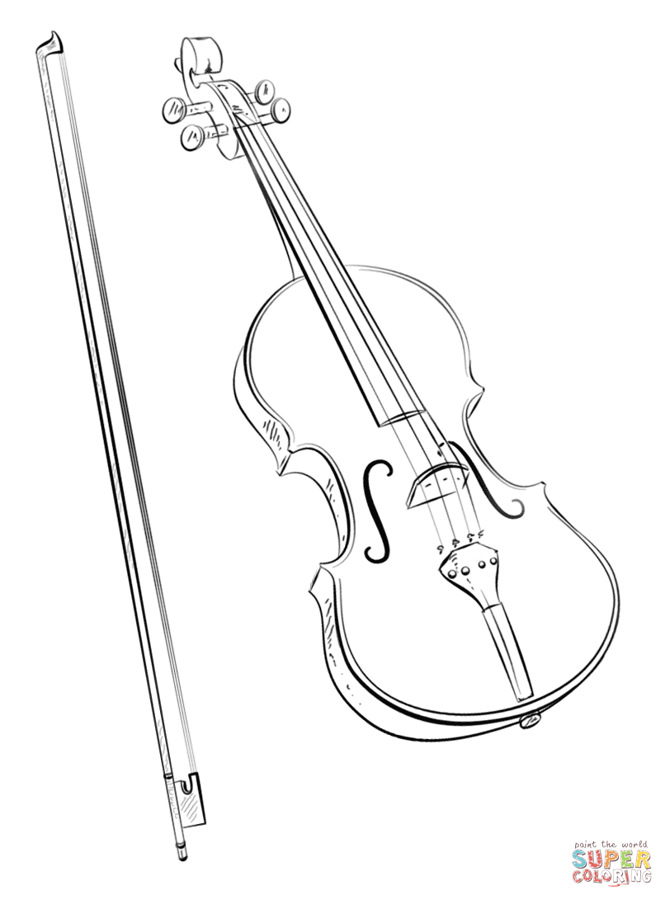

**1ST Homework Assignment:** Due Friday, September 10

1. Review this handbook with your parent/guardian.
2. Be sure to hit the main points:
   * Instrument Rental Info + shoulder rest/rockstop + Orchestra Book
   * Instrument Care and Accident Repair
   * Home Practice Homework (Will vary throughout the trimester)
   * Required Concert Dates (put them on your family calendar)!
   * Concert Outfit
3. Fill out the Google Form (Handbook Form Assignment) and turn in by **Friday, September 10 on Google Classroom.**

**Where Can I Find Orchestra Information throughout the Year?**

**Infinite Campus Email Messages**

* + Mrs. Parker will send group messages through Infinite Campus often. Make sure all off your family’s email addresses are accurate in Infinite Campus.

**Google Classroom**

* + Students will sign up in orchestra class

Go to **www.sjorchestras.weebly.com** for current orchestra information.

Find us on **Facebook** at “**St. Johns Orchestras**” or on **Instagram** at “**stjohnsorchestras**”

to the St. Johns Middle School

|  |
| --- |
| Mrs. Jennifer Parker ⦁ Orchestra Room B101 ⦁ parkerj@sjredwings.org ⦁ 989.227.4357 |
| 6th Grade Orchestra ⦁ 7th Grade Orchestra ⦁ 8th Grade Orchestra  Instruments: Violin, Viola, Cello, Bass  These classes have additional requirements outside of the normal school day,  including **concerts, festivals, clinics, and field trips.** |

Orchestra

*Welcome*

**Daily Instrument Care**

DO put your instrument in its case whenever you are done practicing (loosen bow)

DO wipe the rosin off of your instrument after each practice session with a soft cloth (no cleaning or dusting solution)-**Alcohol-based products will ruin the instrument’s wood and varnish!**

DO ask your orchestra teacher questions about your instrument

DON’T use alcohol of any kind on your instrument. It will damage the wood/varnish

DON’T leave your instrument in the car, outside, in sunlight, or near vents/windows

DON’T touch or move someone else’s instrument without their permission

DON’T let anyone but your orchestra teacher or a luthier play or “fix” your instrument

**What you need Daily (and for all performances and field trips)**

**Violins/Violas**

A violin/viola bow, case, rosin, cleaning cloth, REAL (not foam) shoulder rest.

**Cellos/Basses\***

A cello/bass (at home) with bow, case, rosin, cleaning cloth, rockstop

*\*Bring your instrument to school for Mrs. Parker to check before September 10.*

**ALL Orchestra Students**

* Pencil
* Essential Elements Book 1 (6th Grade Orchestra) or Book 2 (7th Grade Orchestra), Sound Innovations Book 2 (8th Grade Orchestra) for your instrument
* Orchestra Sheet Music
* School-Provided Orchestra Folder

**Daily Musicianship Rubric**

* **Distinguished - 2 Points** (Above and Beyond!)
* **Proficient – 1.5 Points** (Meets Expectations)
* **Basic - 1 Point** (Bare Minimum)
* **Unsatisfactory - 0 Points** (Does Not Contribute)

*Full Rubric posted in classroom.*

**Home Practice Homework**

Your brain learns the skills to play an instrument through **repetition** (practice)

* **75 minutes per week**
* Recommended Schedule:
  + 15-20 minutes (minimum)
  + 5 days per week
* Practice assignments will vary depending on the class, etc. Turn them in on time to get the best results.

**Poor Choice Interventions**

Student Seating Change

Chat with Teacher

Hand Instrument/Bow to Teacher

Parent Contact

Alternate Written Activity

Rehearsal Contract

Student/Parent/Teacher Conference

Administrative Involvement

**Orchestra Grading**

40% - Daily Musicianship/Rehearsal Skills

30% - Concert Attendance, Dress, Etiquette

30% - Assessments, Assignments, Practice

A 93-100% C 73-76%

A- 90-92% C- 70-72%

B+ 87-89% D+ 67-69%

B 83-86% D 63-66%

B- 80-82% D- 60-62%

C+ 77-79% F 0--59%

Orchestra – daily info

**Instrument Care**

Most students take excellent care of their instruments. It is rare for an instrument to need repairs. Here are some things you can do to avoid repair costs:

* Follow your orchestra teacher’s guidelines for good instrument care (covered in class) and ASK if you have questions.
* Rent/purchase instruments only from stores that staff a luthier (repair-person).
* Only let your teacher or a certified luthier (repair-person) fix your instrument.
* ONLY tune your own instrument after you have been taught how to tune in class. Don’t tune with the pegs until you have practiced in class with Mrs. Parker. Parents shouldn’t tune with the pegs unless they have experience tuning an orchestra instrument.

**If you already have an instrument…**

Please bring it to class as soon as possible so Mrs. Parker can make sure it is in good repair and correct for your current body size.

Orchestra – instruments

**How to Find a Good Orchestra Instrument**

1. **Rule of Thumb:** A credible music shop that properly “set up” their instruments will have a luthier (instrument repair person) on staff.
2. Watch out for **deals that are “too good to be true”** (some of these instruments require expensive repair costs).
3. **Painted instruments** are not of adequate quality for orchestra.
4. If you are still growing, **renting your first instrument is recommended.**
5. Mrs. Parker is happy to assist you with finding a quality instrument!

*Please contact Mrs. Parker as soon as possible if it is not financially possible for your family to rent an instrument. Limited scholarships may be available.*

**Field Trips!!!**

*Some field trips may include a student field trip fee (usually $5-$30 per trip). More details provided with specific trip info.*

Demonstration of rehearsal and performances skills is necessary to earn ability to go on trips.

**8th Grade Orchestra Chicago Trip**

There will be a meeting TBA in September to go over this trip’s details (based on School Board approval of the trip)

s

**Required Performances**

“Required” performances are mandatory and will only be excused for emergencies such as illness, a serious family emergency, or extenuating circumstances approved by Mrs. Parker. **Approval for non-emergency absences requires a parent/guardian contacting Mrs. Parker 2 weeks prior to the performance.** Approval will be determined on a case-by-case basis. Make-up assignments for excused performance absences are due before the end of the trimester in which the performance occurred.

**Full Credit for a Performance**

**Looks Like:**

* On time at call time in proper concert attire
* Home instrument, shoulder rest/rockstop, and sheet music
* Respectful Audience Etiquette (no electronics)
* Attentive during warm-ups and quiet backstage
* Maintaining focus/posture during performance and playing your best
* Stay for entire performance (including clean-up)

**Examples of Non-Excused Absences**

A sports team or other practice

“I couldn’t get a ride” (plan ahead, please!)

Homework for another class

**Formal and Casual Performance Attire**

**Formal**  – black slacks, long-sleeved white dress shirt (tucked in) or modest, dressy top with sleeves to elbow or longer, belt, black shoes, well-groomed (trimmed fingernails)

**Casual Attire** – Orchestra t-shirt, black slacks or nice jeans (no holes), OR long black or denim skirt, clean shoes, well-groomed



Orchestra – performances

**\*\*Please pay special attention to important underlined items, which are graded assignments.** ☺

**September 2021**

**24 - MS/HS Orchestra Homecoming Parade 5pm (Report Time TBA)**

**October**

**28 - HS Orchestra Fall Concert @SJHS 7pm**

**November**

**Fundraising Event – Details will come later**

**December**

**4 - MS MSBOA Solo & Ensemble District 5**

**7- 7th & 8th Gr. Orchestra Winter Concert @ SJHS 7pm**

**9- 6th Gr. Orchestra Winter Concert @ SJMS 7pm**

**13 - HS Orchestra Winter Concert @SJHS 7pm**

**17 - HS/MS Christmas Concert SNOW Date - @ SJMS/SJHS**

**January 2022**

**22 - All Star Orchestra (Some 8th grade orchestra students-more info TBA)**

**February**

**12 - HS MSBOA Solo & Ensemble District 5 (Times/Location TBD)**

**March**

**7 - 8th-12th Gr. Orchestra Pre-Festival Concert @SJHS 7:00pm**

**11 or 12 - MSBOA District 5 Band and Orchestra Festival (Times/Location TBD) –8th-12th Gr. Only**

**22 or 23 (TBD) - MS Orchestra Solo & Ensemble @SJMS (Times TBA) – 7th & 8th Gr. Only**

**May**

**13-14 8th Gr. Orchestra Chicago Trip**

**24 - HS Orchestra Spring Concert @ HS Auditorium 7pm**

**June**

**6 - MS Orchestra Spring Concert @ HS Auditorium 7pm – 6th, 7th, & 8th Gr. Students**

|  |
| --- |
| **2021-2022 St. Johns Orchestra Performance Schedule** |
| *PUT THESE ON YOUR FAMILY CALENDAR NOW.*  If there are any additions or cancellations throughout the school year,  orchestra families will be notified in a timely manner. |

Orchestra – calendar